1. What does the command pwd, whoami, and hostname display? (CO1)
Ans. The command pwd displays the current working directory
The command whoami displays the current logged-in username
The command hostname displays the name of the computer or system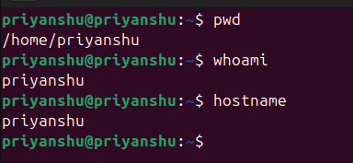

2. Write the command to create a directory named “project” inside the /home/student folder and keep three .txt file into it. Give output snapshot. (CO1)
Ans. 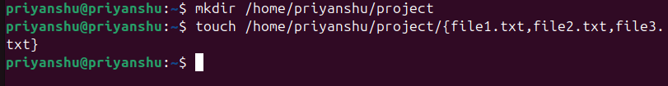

3. Explain the difference between absolute path and relative path with proper examples. (CO2)
Ans. An absolute path is the complete address of a file or directory starting from the root directory / of the Linux file system. It always begins with a forward slash and shows the exact location of a file regardless of where the user currently is. For example, paths like /home/priyanshu/project/file1.txt or /etc/hosts are absolute paths because they give the full directory route from the root. On the other hand, a relative path refers to a file or directory based on the user’s current working directory. It does not start with a / and its meaning changes depending on where the user is located in the directory structure. For instance, if you are inside /home/priyanshu, accessing project/file1.txt is a relative path because it reaches the file by moving from the current directory. Relative paths can also use symbols like . for the current directory and .. for the parent directory, such as ../project/file2.txt. In short, an absolute path gives the full location from the root, while a relative path gives the location from your current position.

4. What command will give you the already executed command traces in the terminal. Give output snapshot. (CO1)
Ans. 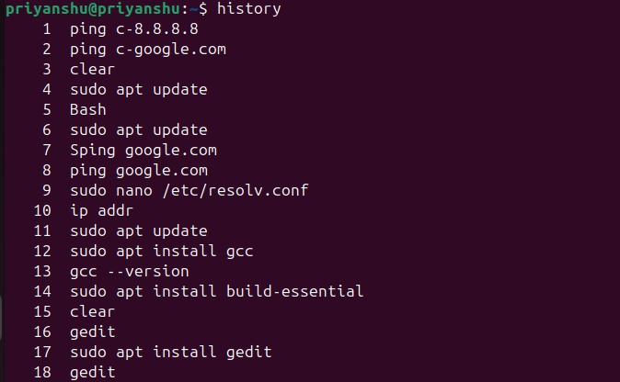

5. Compare the working functionality of find and locate command. Which one is faster and why? (CO1)
Ans.

find | locate
Searches files by scanning the filesystem in real time. | Searches files using a pre-built database.
Slower because it checks every directory and subdirectory. | Much faster because it only queries a database.
Always accurate and reflects the current state of the system. | May miss newly created files if the database is not updated.
Does not need a database; works directly on the filesystem. | Requires database created using updatedb.
Can search by name, size, type, permissions, owner, etc. | Mainly searches by filename only.
Example: find /home -name file.txt | Example: locate file.txt

6. Which command is used to modify file permissions in Linux? Give an example.
Ans. chmod is used to modify permissions in linux.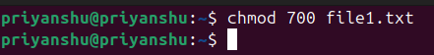

7. A file has permissions -rw -r- -r- -. What does this mean? (CO1)
Ans. The permission string -rw-r--r-- means it is a regular file where the owner has read and write permissions, but cannot execute it. The group members have only read permission, and others (everyone else) also have only read permission. In summary, only the owner can modify the file, while everyone else can only view it.

8. Explain the difference between chown and chgrp with an example. (CO1)
Ans.
chown | chgrp
Used to change the owner of a file or directory. | Used to change the group of a file or directory.
Can modify both owner and group at the same time. | Can modify only the group, not the owner.
Example: chown user1 file.txt | Example: chgrp developers file.txt
Requires higher privileges (root or sudo). | Group members may change the group if allowed.

9. A file needs to be accessible by multiple users but only writable by the owner. How will you set permissions? (CO1)
Ans. To allow multiple users to read a file while only the owner can write to it, you should give read-only permissions to group and others, and read-write permissions to the owner. This is done using the permission mode 644, which corresponds to rw-r--r--.

10. How do you check the manual page for any Linux commands? (CO1)
Ans. We can check the manual page for any Linux command using the man command.
